EXPERIMENT 11
Random Sampling and Sample Distribution

Aim:
To study the Central Limit Theorem by plotting sampling distributions of sample means for different sample sizes using Python.
Procedure:
- Import necessary libraries (numpy, matplotlib).
- Generate a population with a normal distribution (mean = 50, std = 10).
- Define sample sizes (30, 50, 100).
- Draw random samples repeatedly and compute their means.
- Store sample means for each sample size.
- Plot histograms of sample means and compare with the population mean.
Code:
import numpy as np
import matplotlib.pyplot as plt
population_mean = 50 population_std = 10 population_size = 100000
population = np.random.normal(population_mean, population_std, population_size)
sample_sizes = [30, 50, 100] num_samples = 1000
sample_means = {size: [] for size in sample_sizes}
for size in sample_sizes:
for _ in range(num_samples):
sample = np.random.choice(population, size=size, replace=False) sample_means[size].append(np.mean(sample))
plt.figure(figsize=(12, 8)) for i, size in enumerate(sample_sizes):
plt.subplot(len(sample_sizes), 1, i+1)
plt.hist(sample_means[size], bins=30, alpha=0.7, label=f'Sample Size {size}') plt.axvline(np.mean(population), color='red', linestyle='dashed', linewidth=1.5 plt.title(f'Sampling Distribution (Sample Size {size})') plt.xlabel('Sample Mean') plt.ylabel('Frequency') plt.legend()
plt.tight_layout() plt.show()
In [3]:

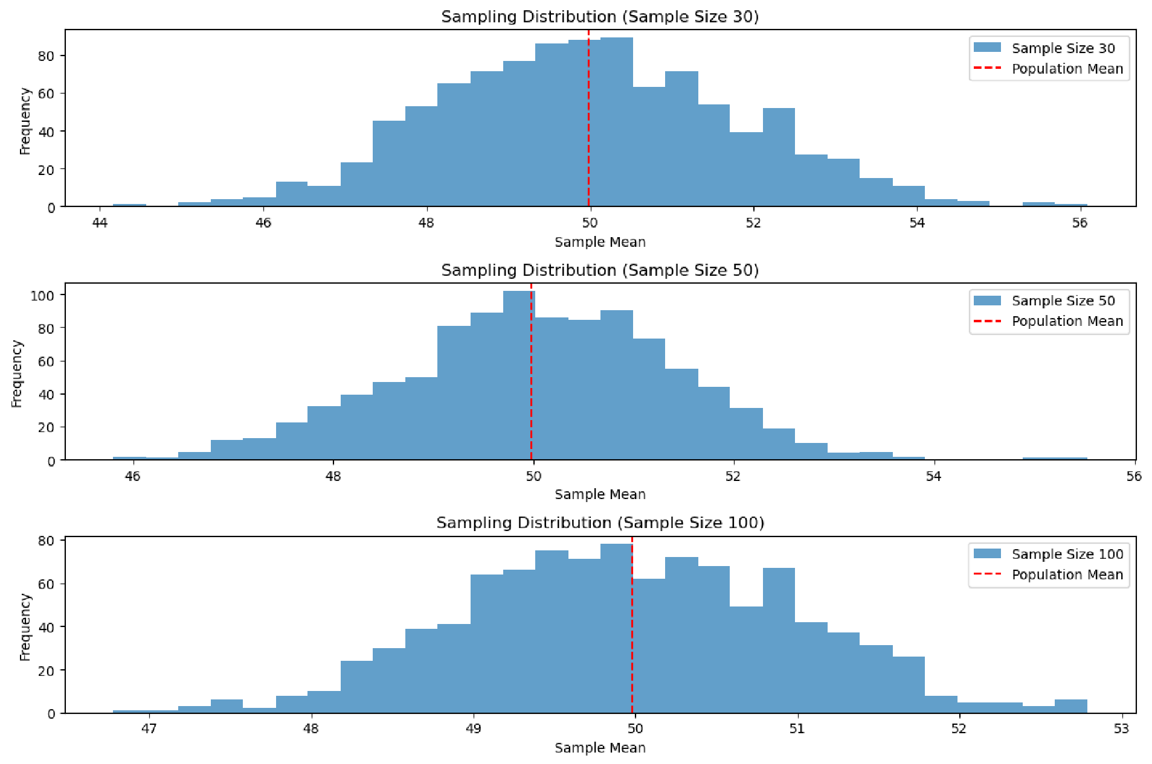

Result:
The sampling distribution of the sample mean approaches a normal distribution as sample size increases, demonstrating the Central Limit Theorem.

